Automated Macro-economic Data Analytics Pipeline

1. Project Overview
This project focuses on building an end-to-end automated data engineering and analytics pipeline for global economic indicators. The pipeline ingests raw macroeconomic data from public APIs, applies data validation and transformation rules, stores analytics-ready datasets, and delivers a business-ready Power BI dashboard for executive-level analysis.
The project demonstrates full ownership of the data lifecycle, including extraction, ingestion, transformation, storage, quality checks, logging, orchestration, alerting, and visualization.
Business Goal
Enable decision-makers to analyse macroeconomic trends, growth patterns, and year-over-year changes across countries and indicators using a reliable, automated data pipeline.

2. Dataset Summary
Sources Used
- World Bank API – Annual macroeconomic indicators
- FRED API – Economic time series (ingested for future enrichment)
Key Fields
- year
- country_code
- indicator_code
- value
- ingested_at

3. Data Extraction & Ingestion (Python)
Python scripts were developed to automatically extract raw economic data from APIs and ingest it into a centralized database.
Steps Performed

● API Extraction
- Pulled annual macroeconomic data programmatically from World Bank
- Pulled selected economic series from FRED for extensibility
● Ingestion Timestamping
- Added ingested_at column to track data freshness and lineage
● Raw Data Storage
- All incoming data stored without modification to preserve source truth

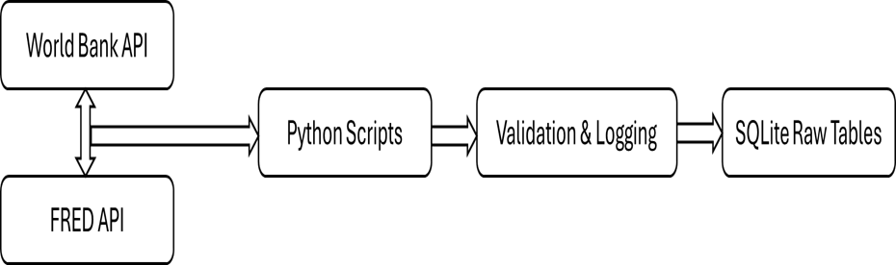

Raw Data Ingestion Flow Diagram

4. Data Storage Layer
Database Used: SQLite
Chosen for simplicity, portability, and analytics-focused workloads.
Tables Created
- raw_macro_data (raw ingestion)
- fact_macro_annual (analytics-ready fact table)
- dim_country
- dim_indicator

5. Data Transformation & Modelling (SQL + Python)
A transformation layer was built to convert raw data into clean, structured analytics tables.
Transformations Applied
● Removed null and empty country and indicator codes
● Enforced correct data types (year as integer)
● Filtered invalid numeric values
● Standardized codes using trimming and validation
● Ensured consistent grain: country × indicator × year
Fact Table
- fact_macro_annual
Dimension Tables
- dim_country
- dim_indicator

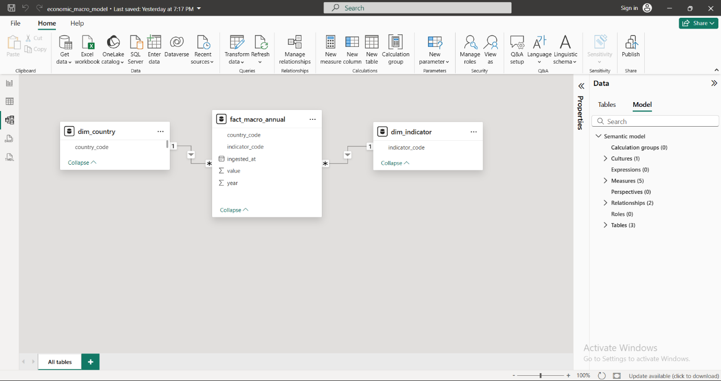
Data Model Diagram

6. Data Validation & Quality Checks
To ensure reliability, automated quality checks were implemented.
Checks Performed
● Row count validation after transformation
● Null value checks on key fields
● Duplicate prevention
● Numeric validity checks on value column
● Schema consistency checks
Failures are logged and flagged immediately.

7. Logging, Monitoring & Email Alerts
A structured logging framework was implemented across the pipeline.

Logging Features
● Step-level logs (start, success, failure)
● Error traceback logging
● Timestamped logs for auditability
Alerting
- Email alerts triggered on pipeline failure
- Enables rapid response and debugging

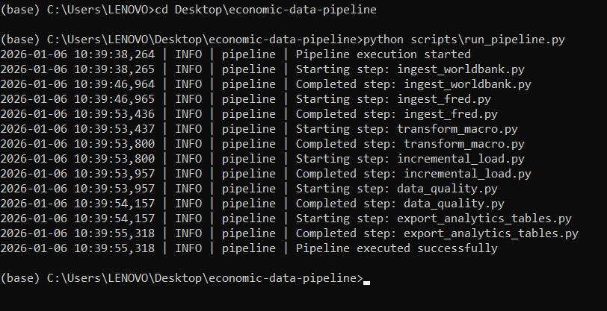
Pipeline execution logs with step-level tracking

8. Pipeline Orchestration & Automation
All scripts were orchestrated into a single executable pipeline.
Pipeline Flow
- Data extraction (World Bank / FRED)
- Raw data ingestion
- Validation checks
- Transformation & modelling
- Quality checks
- Analytics export
- Power BI refresh-ready output

Automation
- Pipeline designed for scheduled execution
- Supports cron / task scheduler integration

Pipeline Orchestration & Execution Flow

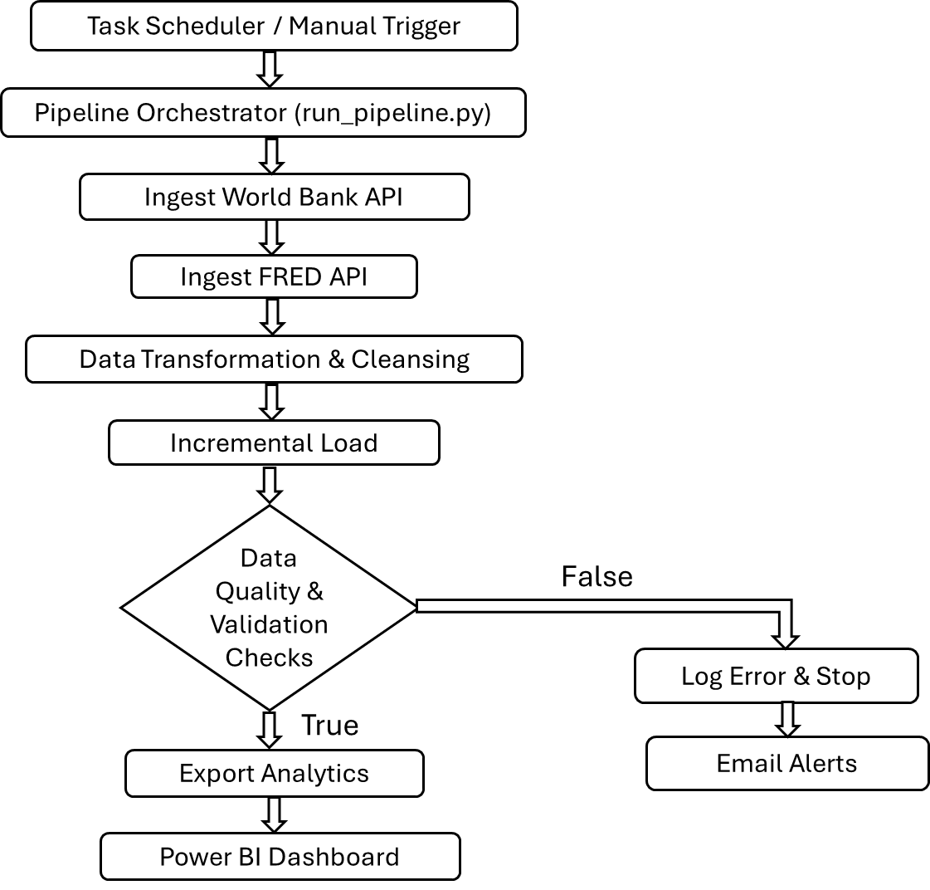

9.Task Scheduling & Automation
To enable fully automated execution, the data pipeline was integrated with Windows Task Scheduler. This ensures the entire workflow runs on a predefined schedule without manual intervention.

Implementation Details:
- Configured a scheduled task to execute run_pipeline.py
- Automated end-to-end execution including:
  - API data ingestion
  - Data transformation and validation
  - Incremental loading
  - Analytics table export
- Enabled continuous data refresh aligned with business reporting cycles

10. Analytics Export Layer
Analytics-ready tables were exported as CSV files for BI consumption.
Exports Generated
- fact_macro_annual.csv
- dim_country.csv
- dim_indicator.csv
This decouples engineering from analytics and enables easy BI refresh.

11. Dashboard in Power BI
A one-page executive dashboard was built for business users.
Dashboard Features
KPI Cards
- Total Value
- Latest Year Value
- YoY Change
- YoY Growth %
- Average value
Visuals
- Trend analysis across years
- Yearly Performance by Country and Indicator
- Country-level analysis
Slicers
- Country
- Indicator
- Year

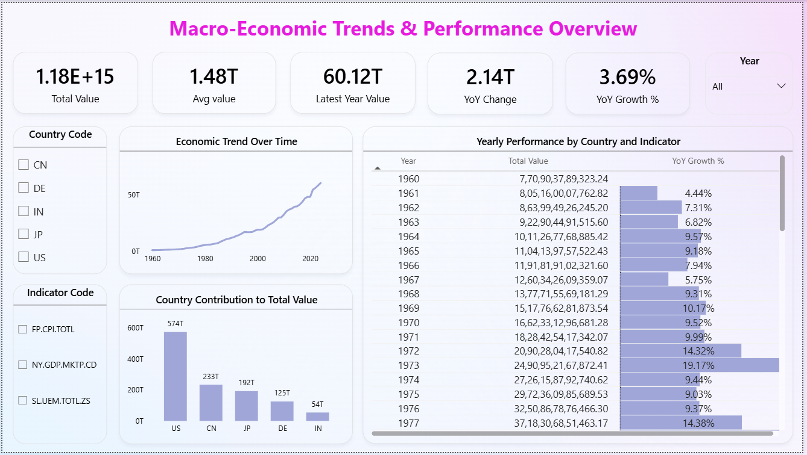

12. Business Insights & Findings

- Long-Term Aggregate Value Has Grown Consistently Over Time
- Recent Period Shows Meaningful Year-over-Year Growth (3.69%)
- Latest Year Contribution Is a Significant Share of Historical Total (60.12T)
- Country Contribution Is Highly Skewed
- Growth Rates Fluctuate Meaningfully Across Years
- Automation Enables Multi-Dimensional Filtering Without Reprocessing
- “US” consistently contribute higher aggregate values across indicators

13. Business Recommendations

- Focus on Growth Indicators
Prioritize indicators that consistently show positive year-over-year growth to identify long-term performance drivers.
- Use Rolling Averages for Stability
Rely on rolling average metrics to smooth short-term volatility and support more stable decision-making.
- Segment Analysis by Indicator
Support aggregate trends with indicator-level analysis to uncover granular drivers behind overall performance.
- Enable Automated Refresh
Schedule automated pipeline executions to ensure dashboards always reflect the most recent available data.
- Extend with Predictive Models
Enhance the solution by adding forecasting and scenario analysis for forward-looking decision support.

